|  |  |  |
| --- | --- | --- |
| SCHOOL OF INFORMATION AND TECHNOLOGY | | |
| NAME: Gerardo, Charles Hanzel D. | DATE PERFORMED: 08/22/2024 | 40/50 |
| Section: IDC2w | DATE SUBMITTED: 08/22/2024 |

# SYSADM1 – Introduction to File Systems in Windows and Linux

# Requirement:

* A virtual machine running Linux and Windows OS

# Instructions:

**Part A: Windows File System**

1. **Open File Explorer:** Click the File Explorer icon on your desktop or press the Windows key + E.  
   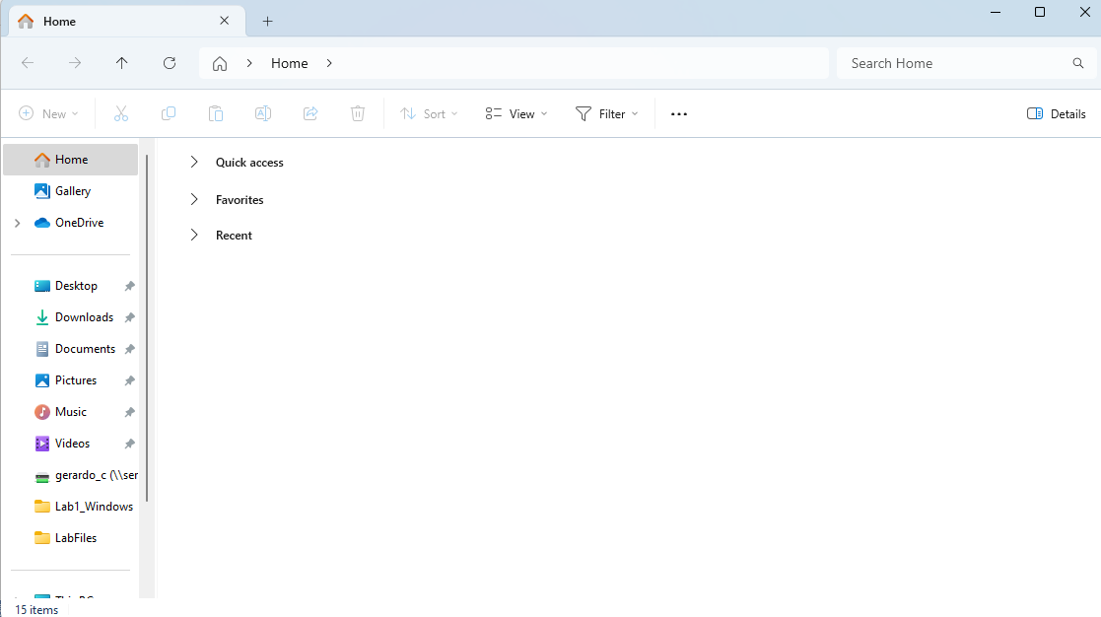
2. **Navigate to your Documents folder:** This is usually the default location for user files.

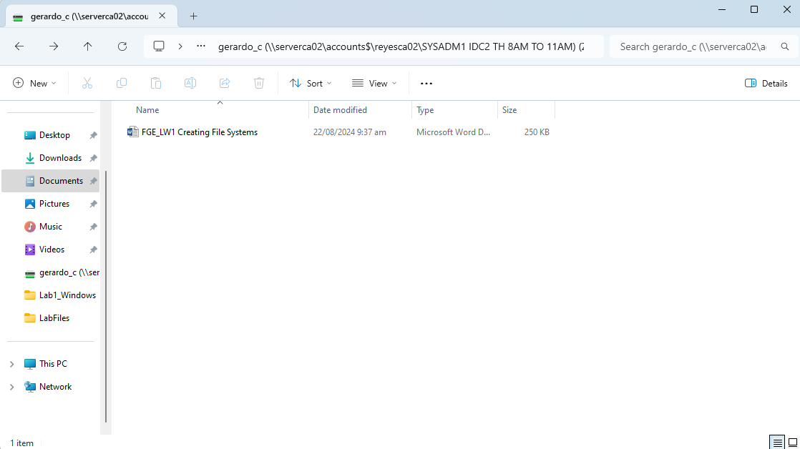

1. **Create a new folder:** Right-click in an empty space, select "New," then "Folder." Name it "Lab1_Windows."  
   
2. **Create a text file:** Right-click in the "Lab1_Windows" folder, select "New," then "Text Document." Rename it to "info.txt."  
   
3. **Open the text file:** Double-click the "info.txt" file to open it in Notepad.  
   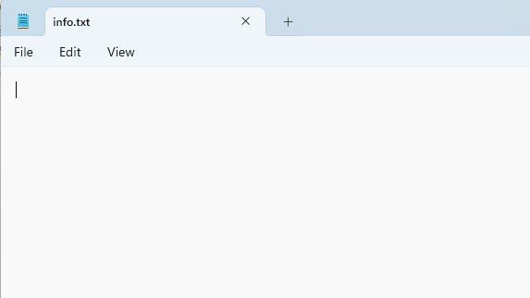
4. **Type some text:** Write a short paragraph about yourself or the purpose of the file.  
   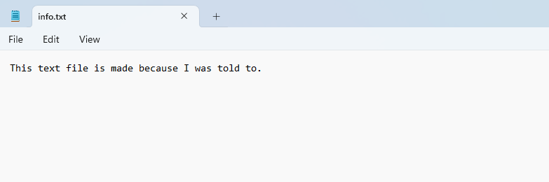
5. **Save the file:** Close the Notepad window and save the changes.  
   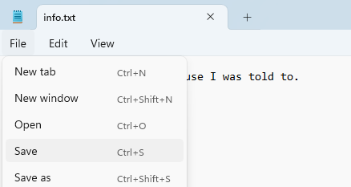
6. **Create a subfolder:** Create a new folder inside "Lab1_Windows" called "Data."  
   
7. **Copy the text file:** Copy the "info.txt" file to the "Data" subfolder.  
   
8. **Rename the copied file:** Rename the copied file to "data.txt.  
   
9. Create a folder named "LabFiles" with subfolders for each file type. Use the internet for the resources of the files listed below.

**LabFiles**

* 1. **Text**
     1. large_text.txt
     2. small_text.txt
     3. code.cpp  
        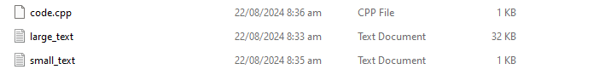
  2. **Images**
     1. image1.jpg
     2. image2.png
     3. image3.bmp  
        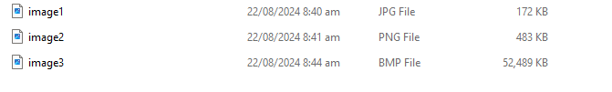
  3. **Audio**
     1. song.mp3
     2. speech.wav  
        
  4. **Video**
     1. clip.mp4  
        

1. **Check file properties:** Right-click on the "info.txt" file and select "Properties." Explore the General, Details, and Security tabs to understand file attributes like creation date, size, and read-only status.
2. **Change file attributes:** Try changing the file attributes (e.g., read-only, hidden) using the Properties dialog. Observe the changes in File Explorer.  
   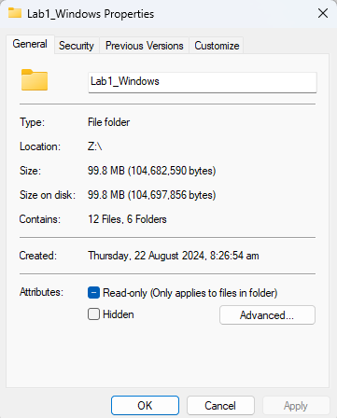
3. **Share the folder:** Right-click on the "Lab1_Windows" folder, select "Properties," and then the "Sharing" tab. Share the folder with a specific user or group, setting appropriate permissions (e.g., Read, Write, Full control)  
   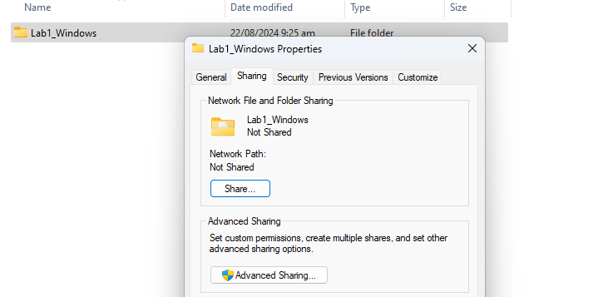
4. **Create an archive:** Use WinRAR or 7-Zip to create a compressed archive of the "Lab1_Windows" folder.  
   
5. **Extract an archive:** Create a new folder, then extract the created archive into it.  
   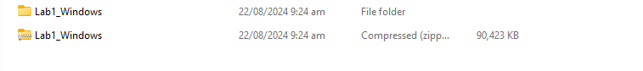

Part B. Create a log report structure

|  |  |  |
| --- | --- | --- |
| Activity Number | Instructions | Screenshots |
| 1 | **Open File Explorer:** Click the File Explorer icon on your desktop or press the Windows key + E. |  |
| 2 | **Navigate to your Documents folder:** This is usually the default location for user files. |  |
| 3 | **Create a new folder:** Right-click in an empty space, select "New," then "Folder." Name it "Lab1_Windows." |  |
| 4 | **Create a text file:** Right-click in the "Lab1_Windows" folder, select "New," then "Text Document." Rename it to "info.txt." |  |
| 5 | **Open the text file:** Double-click the "info.txt" file to open it in Notepad. |  |
| 6 | **Type some text:** Write a short paragraph about yourself or the purpose of the file. |  |
| 7 | **Save the file:** Close the Notepad window and save the changes. |  |
| 8 | **Create a subfolder:** Create a new folder inside "Lab1_Windows" called "Data." |  |
| 9 | **Copy the text file:** Copy the "info.txt" file to the "Data" subfolder. |  |
| 10 | **Rename the copied file:** Rename the copied file to "data.txt. |  |
| 11 | Create a folder named "LabFiles" with subfolders for each file type. Use the internet for the resources of the files listed below.  **Text**  large_text.txt  small_text.txt  code.cpp  **Images**  image1.jpg  image2.png  image3.bmp  **Audio**  song.mp3  speech.wav  **Video**  clip.mp4 |  |
| 12 | **Check file properties:** Right-click on the "info.txt" file and select "Properties." Explore the General, Details, and Security tabs to understand file attributes like creation date, size, and read-only status. |  |
| 13 | **Change file attributes:** Try changing the file attributes (e.g., read-only, hidden) using the Properties dialog. Observe the changes in File Explorer. |  |
| 14 | **Share the folder:** Right-click on the "Lab1_Windows" folder, select "Properties," and then the "Sharing" tab. Share the folder with a specific user or group, setting appropriate permissions (e.g., Read, Write, Full control) |  |
| 15 | **Create an archive:** Use WinRAR or 7-Zip to create a compressed archive of the "Lab1_Windows" folder. |  |
| 16 | **Extract an archive:** Create a new folder, then extract the created archive into it. |  |